Lesson 53

Survey of birds

Characteristics of birds
- Fossils of the earliest birds clearly show reptilian features. Fossils of Archaeopteryx, Sinornis, and Eoalulavis give clues to the origin of flight in birds
- Integumentary, skeletal, muscular, and gas exchange systems of birds are adapted for flight and endothermic temperature regulation
- Large regions of the brain of birds are devoted to integrating sensory information
- Birds’ complex mating systems and behavioral patterns increase the chances of offspring survival
- Migration and navigation allow birds to live, feed, and reproduce in environments
- The body of the birds are covered with feathers
- Birds have horny beaks and scaly feet
- Birds are endothermic vertebrates
- They are oviparous which means they lay eggs to develop their young ones
- Birds are the species in the animal kingdom that walk on two legs. (they are Bipedal)
- Like humans birds have four chambered heart
- The shape of the body is streamlined which helps them to fly high in the sky
- Birds have a very strong vision
- Depending on the species the birds can be said to be carnivores or herbivores creature.

PHYLOGENETIC RELATIONSHIPS
Birds are traditionally classified as members of the class Aves. The major characteristics of this class are adaptations for flight, including appendages modified as wings, feathers, endothermy, a high metabolic rate, a vertebral column modified for flight, and bones lightened by numerous air spaces. In addition, modern birds possess a horny bill and lack teeth. The similarities between birds and reptiles are so striking that birds are often referred to as “glorified reptiles.” Like the crocodilians, birds have descended from ancient archosaurs. Modern birds are derived from the Saurischian lineage of dinosaurs that also included bipedal carnivorous dinosaurs like Tyrannosaurus. According to cladistic interpretations, the birds can be thought of as modern dinosaurs.

ANCIENT BIRDS AND THE EVOLUTION OF FLIGHT
In 1861, one of the most important vertebrate fossils was found in a slate quarry in Bavaria, Germany. It was a fossil of a pigeon-sized animal that lived during the Jurassic period, about 150 million years ago. It had a long, reptilian tail and clawed fingers. The complete head of this specimen was not preserved, but imprints of feathers on the tail and on short, rounded wings were the main evidence that this was the fossil of an ancient bird. It was named Archaeopteryx
(Gr. archaios, ancient pteron, wing). Sixteen years later, a more complete fossil was discovered, revealing teeth in beaklike jaws. Four later discoveries of Archaeopteryx fossils have reinforced the ideas of reptilian ancestry for birds. Most zoologists consider Archaeopteryx to be the oldest bird yet discovered and very close to the main line of evolution between the reptiles and birds.
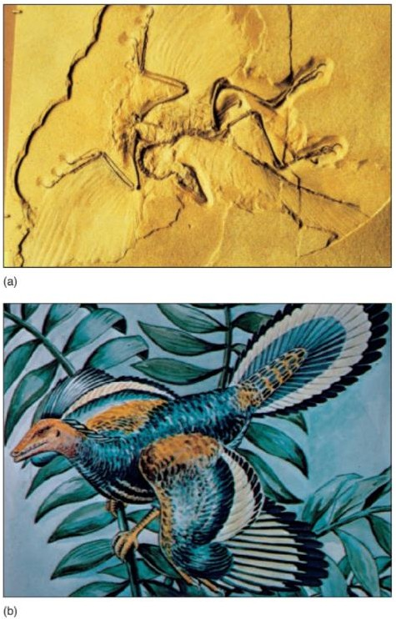
Figure 1: Archaeopteryx an ancient bird a) Archaeopteryx fossil b) Artists representation Some zoologists think that Archaeopteryx was a ground dweller rather than the tree dweller depicted here.
A second ancient bird (Sinornis), discovered in China, fits well with the view that Archaeopteryx was closely related to ancestral bird stocks. Sinornis fossils are 135 million years old—only 15 million years younger than Archaeopteryx.
A very recent discovery of a fossil bird from early Cretaceous deposits in Spain provides additional important information on the origin of flight. This bird, Eoalulavis, was found in 115- million- year-old deposits and had a wingspan of 17 cm (roughly the same as a goldfinch). This fossil showed that Eoalulavis had a wing structure called an alula. As described later in this chapter, the alula is present in many modern birds that engage in slow, hovering flight. Its presence in this fossil indicates that complex flight mechanisms associated with slow, hovering, and highly maneuverable flight evolved at least 115 million years ago.

Lesson 54
DIVERSITY OF MODERN BIRDS
Archaeopteryx, Sinornis, and Eoalulavis provide the only evidence of the transition between reptiles and birds. A variety of fossil birds for the period between 100 million and 70 million years ago has been found. Some of these birds were large, flightless birds; others were adapted for swimming and diving; and some were fliers. Most, like Archaeopteryx, had reptile like teeth. Some of the few birds that survived into the Tertiary period were the ancestors of modern, toothless
birds. The phylogeny of modern birds is controversial. It is sufficient to say that adaptive radiation has resulted in about 9,100 species of living birds, which are divided into about 27 orders (table 21.1). (The number of orders varies, depending on the classification system used.) Characteristic behaviors, songs, anatomical differences, and ecological niches distinguish the orders.
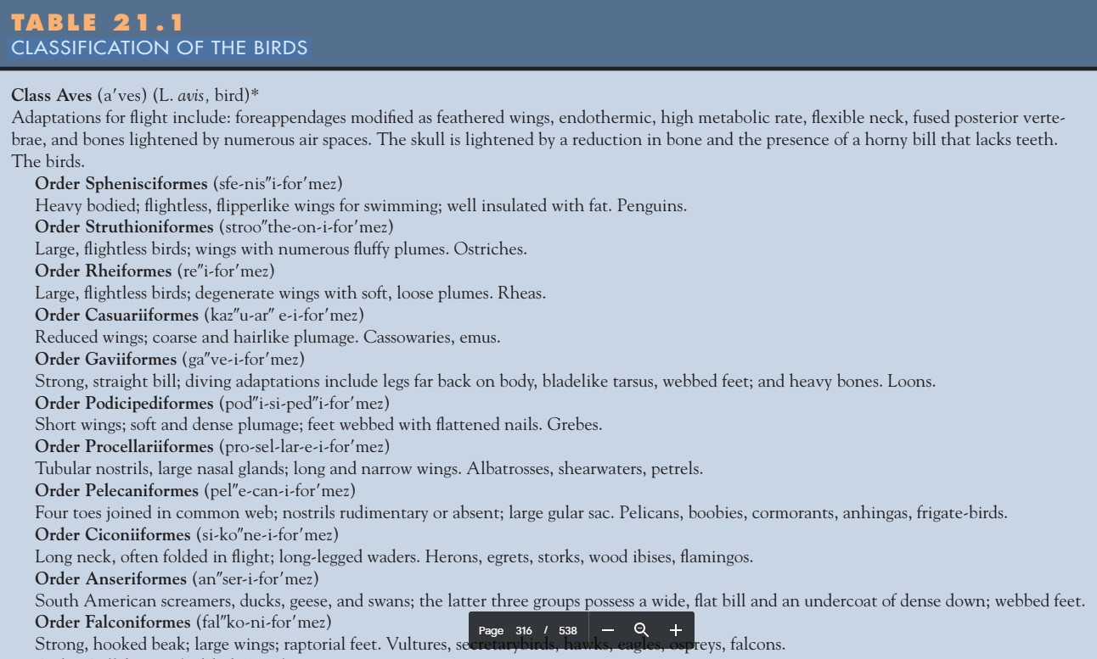

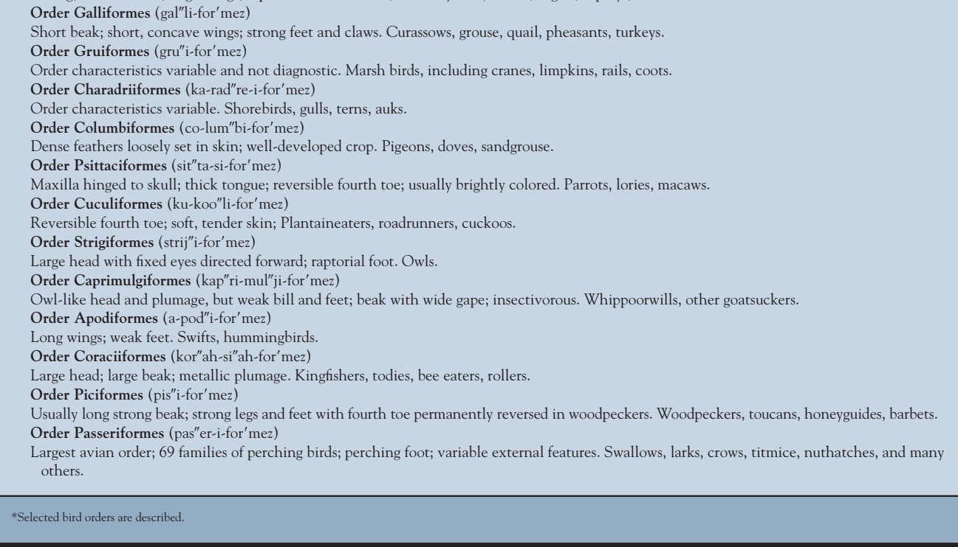

Lesson 55
EVOLUTIONARY PRESSURES: EXTERNAL STRUCTURE AND LOCOMOTION

Evolutionary pressures
Virtually every body system of a bird shows some adaptation for flight. Endothermy, feathers, acute senses, long, flexible necks, and lightweight bones are a few of the many adaptations described in this section.

External structure and locomotion
The covering of feathers on a bird is called the plumage. Feathers have two primary functions essential for flight. They form the flight surfaces that provide lift and aid steering, and they prevent excessive heat loss, permitting the endothermic maintenance of high metabolic rates. Feathers also have roles in courtship, incubation, and waterproofing.
Feathers develop in a fashion similar to the epidermal scales of reptiles, and this similarity is one source of evidence that demonstrates the evolutionary ties between reptiles and birds (figure 21.3). Only the inner pulp of feathers contains dermal elements, such as blood vessels, which supply nutrients and pigments for the growing feather. As feathers mature, their blood supply is cut off, and the feathers become dead, keratinized, epidermal structures seated in epidermal invaginations of the skin called feather follicles.
The most obvious feathers are contour feathers, which cover the body, wings, and tail (Figure 21.4a, c). Contour feathers consist of a vane with its inner and outer webs, and a supportive shaft. Feather barbs branch off the shaft, and barbules branch off the barbs. Barbules of adjacent barbs overlap one another. The ends of barbules lock with hooklike hamuli (sing., hamulus). Interlocking barbs keep contour feathers firm and smooth. Other types of feathers include down feathers, which function as insulating feathers, and filoplume feathers (pinfeathers), which have sensory functions (figure 21.4b, d).
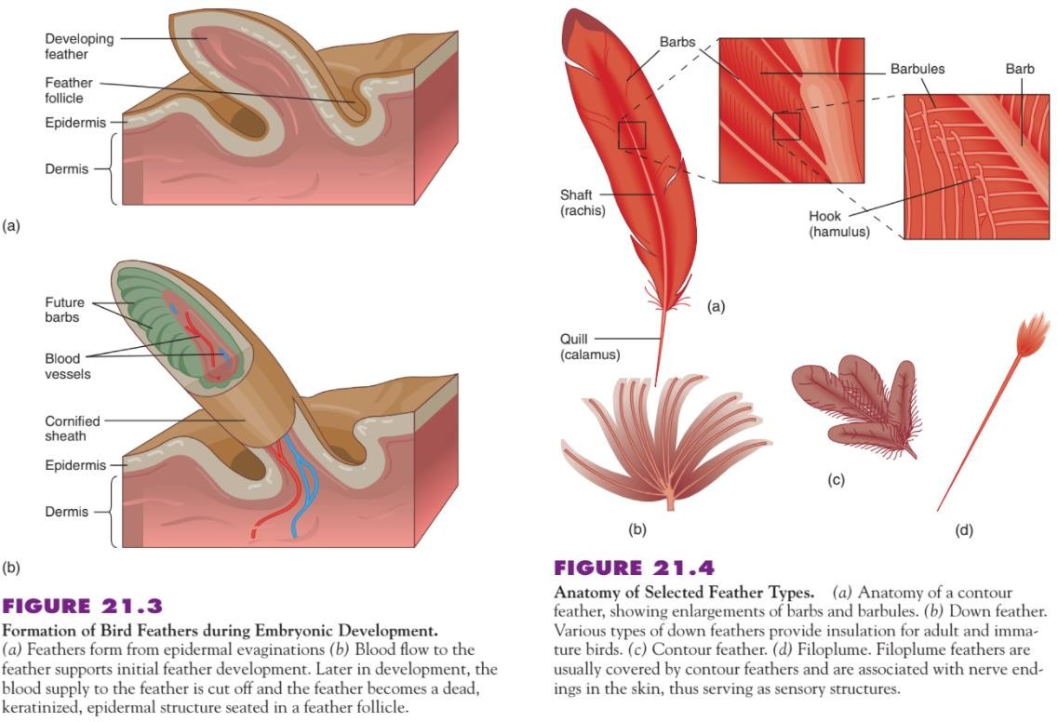

Birds maintain a clean plumage to rid the feathers and skin of parasites. Preening, which is done by rubbing the bill over the feathers, keeps the feathers smooth, clean, and in place. Hamuli that become dislodged can be rehooked by running a feather through the bill. Secretions from an oil gland at the base of the tail of many birds are spread over the feathers during preening to keep the plumage water repellent and supple. The secretions also lubricate the bill and legs to prevent chafing. Anting is a maintenance behavior common to many songbirds and involves picking up ants in the bill and rubbing them over the feathers. The formic acid that ants secrete is apparently toxic to feather mites.
Feather pigments deposited during feather formation produce most colors in a bird’s plumage. Other colors, termed structural colors, arise from irregularities on the surface of the feather that diffract white light. For example, blue feathers are never blue because of the presence of blue pigment. A porous, non-pigmented outer layer on a barb reflects blue wavelengths of light. The other wavelengths pass into the barb and are absorbed by the dark pigment melanin. Iridescence results from the interference of light waves caused by a flattening and twisting of barbules. An example of iridescence is the perception of interchanging colors on the neck and back of hummingbirds and grackles. Color patterns are involved in cryptic coloration, species and sex recognition, and sexual attraction.
Mature feathers receive constant wear; thus, all birds periodically shed and replace their feathers in a process called molting. The timing of molt periods varies in different taxa. The following is a typical molting pattern for songbirds. After hatching, a chick is covered with down. Juvenile feathers replace the down at the juvenile molt. A post juvenile molt in the fall results in plumage similar to that of the adult. Once sexual maturity is attained, a prenuptial molt occurs in late winter or early spring, prior to the breeding season. A postnuptial molt usually occurs between July and October. Flight feathers are frequently lost in a particular sequence so that birds are not wholly deprived of flight during molt periods. However, many ducks, coots, and rails can not fly during molt periods and hide in thick marsh grasses.

Lesson 56 The Skeleton
The bones of most birds are lightweight yet strong. Some bones, such as the humerus (forearm bone), have large air spaces and internal strutting (reinforcing bony bars), which increase strength (figure 21.5c). (Engineers take advantage of this same principle. They have discovered that a strutted girder is stronger than a solid girder of the same weight.) Birds also have a reduced number of skull bones, and a lighter, keratinized sheath called a bill replaces the teeth. The demand for lightweight bones for flight is countered in some birds with other requirements. For example, some aquatic birds (e.g., loons) have dense bones, which help reduce buoyancy during diving.
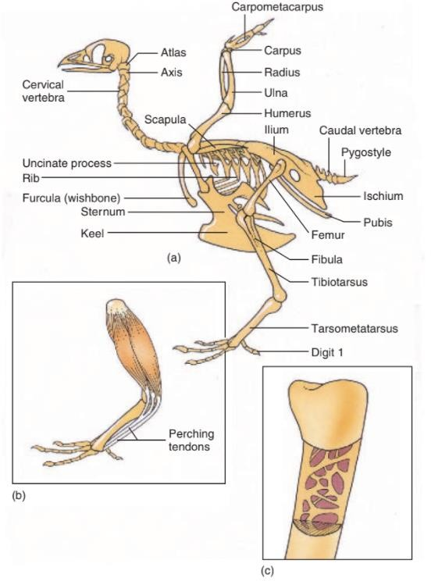
FIGURE 21.5 Bird Skeleton. (a) Skeleton of a pigeon. (b) Perching tendons run from the toes across the back of the ankle joint, which cause the foot to grip a perch. (c) Internal structure of the humerus. Note the air spaces in this pneumatic bone.

The appendages involved in flight cannot manipulate nesting materials or feed young. The bill and very flexible neck and feet make these activities possible. The cervical vertebrae have saddle- shaped articular surfaces that permit great freedom of movement. In addition, the first cervical vertebra (the atlas) has a single point of articulation with the skull (the occipital condyle), which permits a high degree of rotational movement between the skull and the neck. (The single occipital condyle is another characteristic that birds share with reptiles.) This flexibility allows the bill and neck to function as a fifth appendage.
The pelvic girdle, vertebral column, and ribs are strengthened for flight. The thoracic region of the vertebral column contains ribs, which attach to thoracic vertebrae. Most ribs have posteriorly
directed uncinate processes that overlap the next rib to strengthen the rib cage (figure 21.5a). (Uncinate processes are also present on the ribs of most reptiles and are additional evidence of their common ancestry.) Posterior to the thoracic region is the lumbar region. The synsacrum forms by the fusion of the posterior thoracic vertebrae, all the lumbar and sacral vertebrae, and the anterior caudal vertebrae. Fusion of these bones helps to maintain the proper flight posture and supports the hind appendages during landing, hopping, and walking. The posterior caudal vertebrae are fused into a pygostyle, which helps support the tail feathers that are important in steering.
The sternum of most birds bears a large, median keel for the attachment of flight muscles. (Exceptions to this include some flightless birds, such as ostriches.) The keel attaches firmly to the rest of the axial skeleton by the ribs. Paired clavicles fuse medially and ventrally into a furcula (wishbone). The appendages of birds have also been modified. Some bones of the front appendages have been lost or fused, and they are points of attachment for flight feathers. The rear appendages are used for hopping, walking, running, and perching. Perching tendons run from the toes across the back of the ankle joint to muscles of the lower leg. When the ankle joint is flexed, as in landing on a perch, tension on the perching tendons increases, and the foot grips the perch (figure 21.5b). This automatic grasp helps a bird perch even while sleeping.
The muscles of the lower leg can increase the tension on these tendons, for example, when an eagle grasps a fish in its talons.

Muscles
The largest, strongest muscles of most birds are the flight muscles. They attach to the sternum and clavicles and run to the humerus. The muscles of most birds are adapted physiologically for flight. Flight muscles must contract quickly and fatigue very slowly. These muscles have many mitochondria and produce large quantities of ATP to provide the energy required for flight, especially long-distance migrations. Domestic fowl have been selectively bred for massive amounts of muscle (“white meat”) that humans like as food but that is poorly adapted for flight because it contains fibers that can rapidly contract but feature few mitochondria and poor vascularization.

Lesson 57 Flight
The wings of birds are adapted for different kinds of flight. However, regardless of whether a bird soars, glides, or has a rapid flapping flight, the mechanics of staying aloft are similar. Bird wings form an airfoil. The anterior margin of the wing is thicker than the posterior margin. The upper surface of the wing is slightly convex, and the lower surface is flat or slightly concave. Air passing over the wing travels farther and faster than air passing under the wing, decreasing air pressure on the upper surface of the wing and creating lift (figure 21.6a). The lift the wings create must overcome the bird’s weight, and the forces that propel the bird forward must overcome the drag that the bird moving through the air creates. Increasing the angle that the leading edge of the wing
makes with the oncoming air (the angle of attack) increases lift. As the angle of attack increases, however, the flow of air over the upper surface becomes turbulent, reducing lift (figure 21.6b).
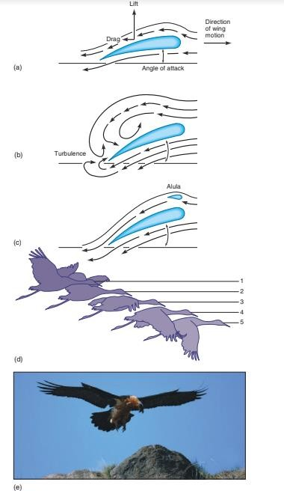
Figure 21.6: Mechanism of bird flight (a) A bird’s wing acts as an airfoil. Air pass over the top of the wing travels farther and faster than air passing under the wing, creating lift. (b) Increasing the angle of attack increases lift but also increases turbulence. (c) The alula reduces turbulence.
(d) Wing orientation during a downstroke. (e) Note the alula on the wings of this bearded vulture (Gypaetus barbatus). This species was widely distributed in the Alps. Excessive hunting nearly eliminated this species around 1900. It is now making a comeback, inhabiting large territories above the Alps forest line.
Turbulence is reduced if air can flow rapidly through slots at the leading edge of the wing. Slotting the feathers at the wing tips and the presence of an alula on the anterior margin of the wing reduce turbulence. The alula is a group of small feathers that bones of the medial digit support. During takeoff, landing, and hovering flight, the angle of attack increases, and the alula is elevated (figure 21.6c,e). During soaring and fast flight, the angle of attack decreases, and slotting is reduced. The distal part of the wing generates most of the propulsive force of flight. Because it is farther from the shoulder joint, the distal part of the wing moves farther and faster than the proximal part of the wing. During the downstroke (the powerstroke), the leading edge of the distal part of the wing is oriented slightly downward and creates a thrust somewhat analogous to the thrust that an airplane propeller creates (figure 21.6d). During the upstroke (the recovery stroke), the distal part of the wing is oriented upward to decrease resistance. Feathers on a wing overlap so that, on the
downstroke, air presses the feathers at the wing margins together, allowing little air to pass between them, enhancing both lift and propulsive forces. Feathers part slightly on the upstroke, allowing air to pass between them, which reduces resistance during this recovery stroke. The tail of a bird serves a variety of balancing, steering, and braking functions during flight. It also enhances lift that the wings produce during low-speed flight. During horizontal flight, spreading the tail feathers increases lift at the rear of the bird and causes the head to dip for descent. Closing the tail feathers has the opposite effect. Tilting the tail sideways turns the bird. When a bird lands, its tail deflects downward, serving as an air brake. In the males of some species—for example, sunbirds (Nectarinia) and widow birds (Euplectes)—tails possess dramatic ornamentation that attracts females and improves reproductive success. Different birds, or the same bird at different times, use different kinds of flight. During gliding flight, the wing is stationary, and a bird loses altitude. Waterfowl coming in for a landing use gliding flight. Flapping flight generates the power for flight and is the most common type of flying. Many variations in wing shape and flapping patterns result in species-specific speed and maneuverability. Soaring flight allows some birds to remain airborne with little energy expenditure. During soaring, wings are essentially stationary, and the bird utilizes updrafts and air currents to gain altitude. Hawks, vultures, and other soaring birds are frequently observed circling along mountain valleys, soaring down-wind to pick up speed and then turning upwind to gain altitude. As the bird slows and begins to lose altitude, it turns downwind again. The wings of many soarers are wide and slotted to provide maximum maneuverability at relatively low speeds. Oceanic soarers, such as albatrosses and frigate birds, have long, narrow wings that provide maximum lift at high speeds, but they compromise maneuverability and ease of takeoff and landing. Hummingbirds perform hovering flight. They hover in still air by fanning their wings back and forth (50 to 80 beats per second) to remain suspended in front of a flower or feeding station
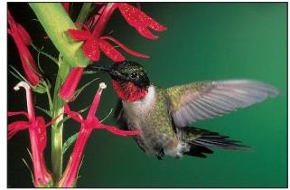
Figure 21.7: Bird Flight and Feeding Adaptations. This ruby-throated humming bird (Archilochus colubris) hovers while feeding on flower nectar. Hummingbird beaks often match the length and curvature of the flower from which the birds extract nectar.

Lesson 58
NUTRITION AND THE DIGESTIVE SYSTEM
Most birds have ravenous appetites! This appetite supports a high metabolic rate that makes endothermy and flight possible. For example, hummingbirds feed almost constantly during the day. In spite of high rates of food consumption, they often cannot sustain their rapid metabolism overnight, and they may become torpid, with reduced body temperature and respiratory rate, until they can feed again in the morning. Bird bills and tongues are modified for a variety of feeding habits and food sources (figures 21.7 and 21.8). For example, a woodpecker’s tongue is barbed for extracting grubs from the bark of trees (see figure 27.6d). Sapsuckers excavate holes in trees and use a brush like tongue for licking the sap that accumulates in these holes. The tongues of hummingbirds and other nectar feeders roll into a tube for extracting nectar from flowers. In many birds, a diverticulum of the esophagus, called the crop, is a storage structure that allows birds to quickly ingest large quantities of locally abundant food. They can then seek safety while digesting their meal. The crop of pigeons produces “pigeon’s milk,” a cheesy secretion formed by the proliferation and sloughing of cells lining the crop. Young pigeons (squabs) feed on pigeon’s milk until they are able to eat grain. Cedar waxwings, vultures, and birds of prey use their esophagus for similar storage functions.
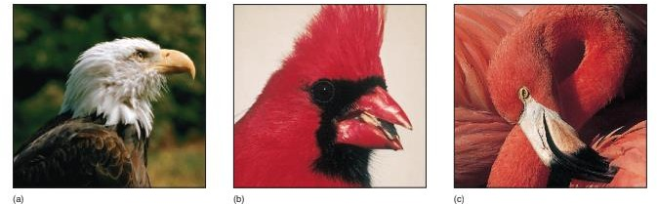
Figure 21.8: (a) The bill of a bald eagle (Haliacetus leucocephalus) is specialized for tearing prey.
(b) The thick, powerful bill of this cardinal (Cardinalis cardinalis) cracks tough seeds. (c) The bill of a flamingo (Phoenicopterus ruber) strains food from the water in a head-down feeding posture. Large bristles fringe the upper and lower mandibles. As water is sucked into the bill, larger particles are filtered and left outside. Inside the bill, tiny inner bristles filter smaller algae and animals. The tongue removes food from the bristles.

Crops are less well developed in insect-eating birds because insectivorous birds feed throughout the day on sparsely distributed food. The stomach of birds is modified into two regions. The proventriculus secretes gastric juices that initiate digestion (figure 21.9). The ventriculus (gizzard) has muscular walls to abrade and crush seeds or other hard materials. Birds may swallow sand and other abrasives to aid digestion. The bulk of enzymatic digestion and absorption occurs in the small intestine, aided by secretions from the pancreas and liver. Paired ceca may be located at the union
of the large and small intestine. These blind-ending sacs contain bacteria that aid in cellulose digestion. Birds usually eliminate undigested food through the cloaca; however, owls form pellets of bone, fur, and feathers that are ejected from the ventriculus through the mouth. Owl pellets accumulate in and around owl nests and are useful in studying their food habits.

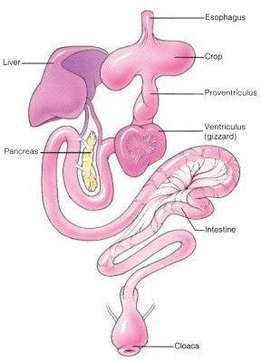
Figure 21.9: Digestive System of a Pigeon. Birds have high metabolic rates that require a nearly constant nutrient supply.

Birds are often grouped by their feeding habits. These groupings are somewhat artificial, however, because birds may eat different kinds of food at different stages in their life history, or they may change diets simply because of changes in food availability. Robins, for example, feed largely on worms and other invertebrates when these foods are available. In the winter, however, robins may feed on berries.

Feeding habits of birds
In some of their feeding habits, birds directly conflict with human interests. Bird damage to orchard and grain crops is tallied in the millions of dollars each year. Flocking and roosting habits of some birds, such as European starlings and redwing blackbirds, concentrate millions of birds in local
habitats, where they devastate fields of grain. Recent monocultural practices tend to aggravate problems with grain-feeding birds by encouraging the formation of very large flocks.
Birds of prey have minimal impact on populations of poultry and game birds, and on commercial fisheries. Unfortunately, the mistaken impression that they are responsible for significant losses has led humans to poison and shoot them.

Lesson 59
CIRCULATION, GAS EXCHANGE, AND TEMPERATURE REGULATION

Circulation
The circulatory system of birds is similar to that of reptiles, except that the heart has completely separated atria and ventricles, resulting in separate pulmonary and systemic circuits. This separation prevents any mixing of highly oxygenated blood with less oxygenated blood. In vertebrate evolution, the sinus venosus has gradually decreased in size. It is a separate chamber in fishes, amphibians, and turtles and receives blood from the venous system. In other reptiles, it is a group of cells in the right atrium that serves as the pacemaker for the heart. In birds, the sinus venosus also persists only as a patch of pacemaker tissue in the right atrium. The bird heart is relatively large (up to 2.4% of total body weight), and it beats rapidly. Rates in excess of 1,000 beats per minute have been recorded for hummingbirds under stress. Larger birds have relatively smaller hearts and slower heart rates. The heart rate of an ostrich, for example, varies between 38 and 176 beats per minute. A large heart, rapid heart rate, and complete separation of highly oxygenated from less oxygenated blood are important adaptations for delivering the large quantities of blood required for endothermy and flight.

GAS EXCHANGE
The respiratory system of birds is extremely complex and efficient. It consists of external nares, which lead to nasal passageways and the pharynx. Bone and cartilage support the trachea. A special voice box, called the syrinx, is located where the trachea divides into bronchi. The muscles of the syrinx and bronchi, as well as characteristics of the trachea, produce bird vocalizations. The bronchi lead to a complex system of air sacs that occupy much of the body and extend into some of the bones of the skeletal system (figure 21.10a). The air sacs and bronchi connect to the lungs. The lungs of birds are made of small air tubes called parabronchi.
Air capillaries about 10 mm in diameter branch from the parabronchi and are associated with capillary beds for gas exchange. Inspiration and expiration result from increasing and decreasing the volume of the thorax and from alternate expansion and compression of air sacs during flight and other activities. During breathing, the movement of the sternum and the posterior ribs compresses the thoracic air sacs. X-ray movies of European starlings in a wind tunnel show that the contraction of flight muscles distorts the furcula. Alternate distortion and recoiling helps compress and expand air sacs between the bone’s two shafts. During inspiration, air moves into the abdominal air sacs. At the same time, air already in the lungs moves through parabronchi into the thoracic air sacs (figure 21.10b, cycle 1). During expiration, the air in the thoracic air sacs moves out of the respiratory system, and the air in the abdominal air sacs moves into parabronchi (figure 21.10c). At the next inspiration (figure 21.10b, cycle 2), the air moves into the thoracic air sacs, and it is expelled during the next expiration. It takes two ventilatory cycles to move a particular volume of air through the respiratory system of a bird.
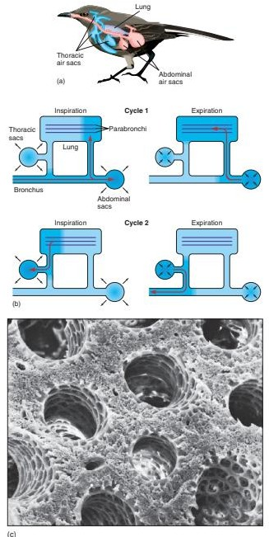
Figure 21.10 Respiratory System of a Bird. (a) Air sacs branch from the respiratory tree. (b) Air flow during inspiration and expiration. Air flows through the parabronchi during both inspiration and expiration. The shading represents the movement through the lungs of one inspiration. (c) Scanning electron micrograph of parabronchi.

Because of high metabolic rates associated with flight, birds have a greater rate of oxygen consumption than any other vertebrate. When other tetrapods inspire and expire, air passes into and out of respiratory passageways in a simple back-and-forth cycle. Ventilation is interrupted during expiration, and much “dead air” (air not forced out during expiration) remains in the lungs. Because of the unique system of air sacs and parabronchi, bird lungs have a nearly continuous movement of oxygen-rich air over respiratory surfaces during both inspiration and expiration. The quantity of “dead air” in the lungs is sharply reduced, compared with other vertebrates.
This avian system of gas exchange is more efficient than that of any other tetrapod. In addition to supporting high metabolic rates, this efficient gas exchange system probably also explains how birds can live and fly at high altitudes, where oxygen tensions are low. During their migrations, bar-headed geese fly over the peaks of the Himalayas at altitudes of 9,200 m. A human mountain climber begins to feel the symptoms of altitude sickness and must carry auxiliary oxygen supplies above 2,500 m.

Thermoregulation
Birds maintain body temperatures between 38 and 45° C. Lethal extremes are lower than 32 and higher than 47° C. On a cold day, a resting bird fluffs its feathers to increase their insulating properties, as well as the dead air space within them. It also tucks its bill into its feathers to reduce heat loss from the respiratory tract. The most exposed parts of a bird are the feet and tarsi, which have neither fleshy muscles nor a rich blood supply. Temperatures in these extremities are allowed to drop near freezing to prevent heat loss. Countercurrent heat exchange between the warm blood flowing to the legs and feet, and the cooler blood flowing to the body core from the legs and feet, prevents excessive heat loss at the feet. Heat is returned to the body core before it goes to the extremities and is lost to the environment (see figure 28.5b). Shivering also generates heat in extreme cold. Increases in metabolism during winter months require additional food.
Some birds become torpid and allow their body temperatures to drop on cool nights. For example, whippoorwills allow their body temperatures to drop from about 40° C to near 16° C, and respiratory rates become very slow. Muscular activity during flight produces large quantities of heat, which birds can dissipate by panting. Evaporative heat loss from the floor of the mouth is enhanced by fluttering vascular membranes of this region.

Lesson 60
NERVOUS AND SENSORY SYSTEMS
The forebrain of birds is much larger than that of reptiles due to the enlargement of the cerebral hemispheres, including a region of gray matter, the corpus striatum. The corpus striatum functions in visual learning, feeding, courtship, and nesting. A pineal body on the roof of the forebrain appears to stimulate ovarian development and to regulate other functions influenced by light and dark periods. The optic tectum (the roof of the mid brain), along with the corpus striatum, plays an important role in integrating sensory functions. The midbrain also receives sensory input from the eyes. As in reptiles, the hindbrain includes the cerebellum and the medulla oblongata, which coordinate motor activities and regulate heart and respiratory rates, respectively.
Vision is an important sense for most birds. The structures of bird eyes are similar to those of other vertebrates, but bird eyes are much larger relative to body size than those of other vertebrates (see figure 19.14). The eyes are usually somewhat flattened in an anteroposterior direction; however, the eyes of birds of prey protrude anteriorly because of a bulging cornea. Birds have a unique double-focusing mechanism. Padlike structures (similar to those of reptiles) control the curvature of the lens, and ciliary muscles change the curvature of the cornea. Double, nearly instantaneous focusing allows an osprey or other bird of prey to remain focused on a fish throughout a brief, but breathtakingly fast, descent. The retina of a bird’s eye is thick and contains both rods and cones. Rods are active under low light intensities, and cones are active under high light intensities. Cones are especially concentrated (1,000,000/mm2) at a focal point called the fovea.
Unlike other vertebrates, some birds have two foveae per eye. The one at the center of the retina is sometimes called the “search fovea” because it gives the bird a wide angle of monocular vision. The other fovea is at the posterior margin of the retina. It functions with the posterior fovea of the
other eye to allow binocular vision. The posterior fovea is called the “pursuit fovea” because binocular vision produces depth perception, which is necessary to capture prey. The words “search” and “pursuit” are not meant to imply that only predatory birds have these two foveae. Other birds use the “search fovea” to observe the landscape below them during flight and the “pursuit” fovea when depth perception is needed, as in landing on a branch of a tree.
The position of the eyes on the head also influences the degree of binocular vision (figure 21.12). Pigeons have eyes located well back on the sides of their head, giving them a nearly 360° monocular field, but a narrow binocular field. They do not have to pursue their food (grain), and a wide monocular field of view helps them stay alert to predators while feeding on the ground. Hawks and owls have eyes farther forward on the head. This increases their binocular field of view and correspondingly decreases their monocular field of view.
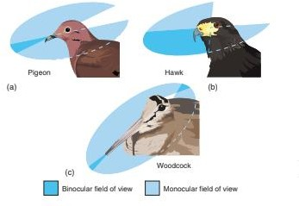
Figure 21.12: Avian Vision. The fields of view of (a) a pigeon, (b) a hawk, and (c) a woodcock. Woodcocks have eyes located far posteriorly and have a narrow field of binocular vision in front and behind. They can focus on predators circling above them while probing mud with their long beaks.

Like reptiles, birds have a nictitating membrane that is drawn over the surface of the eye to cleanse and protect the eye. Olfaction apparently plays a minor role in the lives of most birds. External nares open near the base of the beak, but the olfactory epithelium is poorly developed. Exceptions include turkey vultures, which locate their dead and dying prey largely by smell.
In contrast, most birds have well-developed hearing. Loose, delicate feathers called auriculars cover the external ear opening. Middle- and inner-ear structures are similar to those of reptiles. The sensitivity of the avian ear (100 to 15,000 Hz) is similar to that of the human ear (16 to 20,000 Hz).

Lesson 61
EXCRETION AND OSMOREGULATION, REPRODUCTION AND DEVELOPMENT

Excretion and osmoregulation
Birds and reptiles face essentially identical excretory and osmoregulatory demands. Like reptiles, birds excrete uric acid, which is temporarily stored in the cloaca. Water is also reabsorbed in the cloaca. As with reptiles, the excretion of uric acid conserves water and promotes embryo development in terrestrial environments. In addition, some birds have supraorbital salt glands that drain excess sodium chloride through the nasal openings to the outside of the body. These are especially important in marine birds that drink seawater and feed on invertebrates containing large quantities of salt in their tissues. Salt glands can secrete salt in a solution that is two to three times more concentrated than other body fluids. Salt glands, therefore, compensate for the kidney’s in- ability to concentrate salts in the urine.

Reproduction and development
Sexual activities of birds have been observed more closely than those of any other group of animals. These activities include establishing territories, finding mates, constructing nests, incubating eggs, and feeding young. All birds are oviparous. Gonads are in the dorsal abdominal region, next to the kidneys. Testes are paired, and coiled tubules (vasa deferentia) conduct sperm to the cloaca. An enlargement of the vasa deferentia, the seminal vesicle, is a site for temporary storage and maturation of sperm prior to mating. Testes enlarge during the breeding season. Except for certain waterfowl and ostriches, birds have no intromittent organ, and sperm are transferred by cloacal contact when the male briefly mounts the female. In females, two ovaries form during development, but usually only the left ovary fully develops (figure 21.13). A large, funnel-shaped opening (the ostium) of the oviduct envelops the novary and receives eggs after ovulation. The egg is fertilized in the upper portions of the oviduct, and albumen that glandular regions of the oviduct wall secrete gradually surrounds the zygote as it completes its passage. A shell gland in the lower region of the oviduct adds a shell. The oviduct opens into the cloaca.
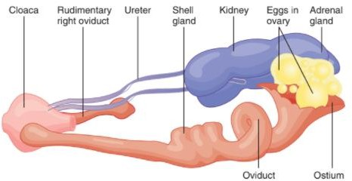
Figure 21.13: Urogenital System of a Female Pigeon. The right ovary and oviduct are rudimentary in most female birds.

Many birds establish territories prior to mating. Although size and function vary greatly among species, territories generally allow birds to mate without interference. They provide nest locations and sometimes food resources for adults and offspring. Breeding birds defend their territories and expel intruders of the same sex and species. Threats are common, but actual fighting is minimal. Mating may follow the attraction of a mate to a territory. For example, male woodpeckers drum on trees to attract females. Male ruffed grouse fan their wings on logs and create sounds that can be heard for many miles. Cranes have a courtship dance that includes stepping, bowing, stretching, and jumping displays. Mating occurs when a mate’s call or posture signals readiness. It happens quickly but repeatedly to assure fertilization of all the eggs that will be laid.
Most birds are monogamous. A single male pairs with a single female during the breeding season. Some birds (swans, geese, eagles) pair for life. Frequent mating apparently strengthens the pair bonds that develop. Monogamy is common when resources are widely and evenly distributed, and one bird cannot control access to resources. Monogamy is also advantageous because both parents usually participate in nest building and care of the young. One parent incubates and protects the eggs or chicks while the other searches for food.
Some birds are polygynous. Males mate with more than one female, and the females care for the eggs and chicks. Polygyny tends to occur in species whose young are less dependent at hatching and in situations where patchy resource distribution may attract many females to a relatively small breeding area. Prairie chickens are polygynous, and males display in groups called leks. In prairie chicken leks, the males in the center positions are preferred and attract the majority of females (figure 21.14). A few bird species are polyandrous, and the females mate with more than one male. For example, female spotted sandpipers are larger than males, and they establish and defend their territories from other females. They lay eggs for each male that is attracted to and builds a nest in their territory. If a male loses his eggs to a predator, the female replaces them. Polyandry results in the production of more eggs than in monogamous matings. It is thought to be advantageous when food is plentiful but, because of predation or other threats, the chances of successfully rearing young are low. Nest construction usually begins after pair formation. The female usually initiates this instinctive behavior. A few birds do not make nests. Emperor penguins, for example, breed on the snow and ice of Antarctica, where no nest materials are available. Their single egg is incubated on the web of the foot (mostly the male’s foot), tucked within a fold of abdominal skin.

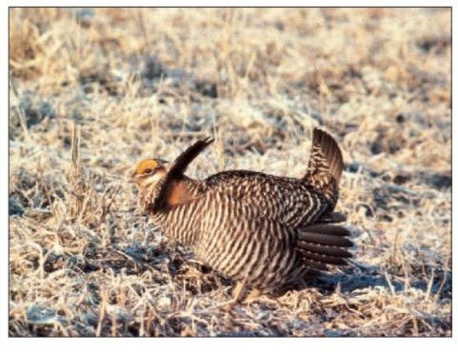

Figure 21.14: Courtship Displays. A male greater prairie chicken (Tympanuchus cupido) displaying in a lek.

Nesting Activities
The nesting behavior of birds is often species specific. Some birds choose nest sites away from other members of their species, and other birds nest in large flocks. Unfortunately, predictable nesting behavior has led to the extinction of some species of birds. The group of eggs laid and chicks produced by a female is called a clutch. Clutch size usually varies. Most birds incubate their eggs, and some birds have a featherless, vascularized incubation or brood patch (see figure 25.13) that helps keep the eggs at temperatures between 33 and 37° C. Birds turn the eggs to prevent egg membranes from adhering in the egg and deforming the embryo. Adults of some species sprinkle the eggs with water to cool and humidify them. The Egyptian plover carries water from distant sites in the breast feathers. The incubation period lasts between 10 and 80 days and correlates with egg size and degree of development at hatching. One or two days before hatching, the young bird penetrates an air sac at the blunt end of its egg, inflates its lungs, and begins breathing. Hatching occurs as the young bird pecks the shell with a keratinized egg tooth on the tip of the upper jaw and struggles to free itself.
Some birds are helpless at hatching; others are more independent. Those that are entirely dependent on their parents are said to be altricial (L. altricialis, to nourish), and they are often naked at hatching (figure 21.15a). Altricial young must be brooded constantly at first because endothermy is not developed. They grow rapidly, and when they leave the nest, they are nearly as large as their parents. For example, American robins weigh 4 to 6 g at hatching and leave the nest 13 days later weighing 57 g. Precocial (L. pracoci, early ripe) young are alert and lively at hatching (figure 21.15b). They are usually covered with down and can walk, run swim, and feed themselves— although one parent is usually present to lead the young to food and shelter. Young altricial birds have huge appetites and keep one or both parents continually searching for food. They may consume a mass of food that equals their own weight each day. Adults bring food to the nest or regurgitate food stored in the crop or esophagus. Vocal signals or color patterns on the bills or throats of adults initiate feeding responses in the young. Parents instinctively feed gaping mouths, and many hatchlings have brightly colored mouth linings or spots that attract a parent’s attention. The first-hatched young is fed first—most often because it is usually the largest and can stretch its neck higher than can its nestmares. Life is usually brief for birds. About 50% of eggs laid yield birds that leave the nest. Most birds, if kept in captivity, have a potential life span of 10 to 20 years. Natural longevity is much shorter. The average American robin lives 1.3 years, and the average black-capped chickadee lives less than 1 year. Mortality is high in the first year from predators and inclement weather.

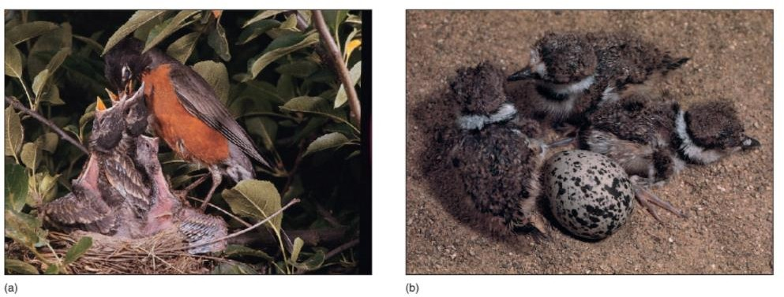
FIGURE 21.15 Altricial and Precocial Chicks. (a) An American robin (Turdus migratorius) feeding nestlings. Robins have altricial chicks that are helpless at hatching. (b) Killdeer (Charadrius vociferus) have precocial chicks that are down covered and can move about.

Lesson 62
MIGRATION AND NAVIGATION
Migration (as used here) refers to periodic round trips between breeding and nonbreeding areas. Most migrations are annual, with nesting areas in northern regions and wintering grounds in the south. (Migration is more pronounced for species found in the Northern Hemisphere because about 70% of the earth’s land is in the Northern Hemisphere.) Migrations occasionally involve east/west movements or altitude changes. Migration allows birds to avoid climatic extremes and to secure adequate food, shelter, and space throughout the year.
Birds migrate in response to species-specific physiological conditions. Innate (genetic) clocks and environmental factors influence preparation for migration. The photoperiod is an important migratory cue for many birds, particularly for birds in temperate zones. The changing photoperiod initiates seasonal changes in gonadal development that often serve as migratory stimuli. Increasing day length in the spring promotes gonadal development, and decreasing day length in the fall initiates gonadal regression. In many birds, the changing photoperiod also appears to promote fat deposition, which acts as an energy reserve for migration. The anterior lobe of the pituitary gland and the pineal body have been implicated in mediating photoperiod responses. The mechanics of migration are species specific. Some long distance migrants may store fat equal to 50% of their body weight and make nonstop journeys. Other species that take a more leisurely approach to migration begin their journeys early and stop frequently to feed and rest. In clear weather, many birds fly at altitudes greater than 1,000 m, which reduces the likelihood of hitting tall obstacles. Many birds have very specific migration routes.

Navigation
Homing pigeons have served for many years as a pigeon postal service. In ancient Egyptian times and as recently as World War II, pigeons returned messages from the battlefield. Birds use two forms of navigation. Route-based navigation involves keeping track of landmarks (visual or auditory) on an outward journey so that those landmarks can be used in a reverse sequence on the return trip. Location-based navigation is based on establishing the direction of the destination from information available at the journey’s site of origin. It involves the use of sun compasses, other celestial cues, and/or the earth’s magnetic field. Birds’ lenses are transparent to ultraviolet light, and their photoreceptors respond to it, allowing them to orient using the sun, even on cloudy days. This orientation cue is called a sun compass. Because the sun moves through the sky between sunrise and sunset, birds use internal clocks to perceive that the sun rises in the east, is approximately overhead at noon, and sets in the west. The biological clocks of migratory birds can be altered. For example, birds ready for northward migration can be held in a laboratory in which the “laboratory sunrise” occurs later than the natural sunrise. When released to natural light conditions, they fly in a direction they perceive to be north, but which is really north-west. Night migrators can also orient using the sun by flying in the proper direction from the sunset.
Celestial cues other than the sun can be used to navigate. Humans recognize that in the Northern Hemisphere, the North Star lines up with the axis of rotation of the earth. The angle between the North Star and the horizon decreases as you move toward the equator. Birds may use similar information to determine latitude. Experimental rotations of the night sky in a planetarium have altered the orientation of birds in test cages. Some zoologists have long speculated that birds employ magnetic compasses to detect the earth’s magnetic field, and thus, determine direction. Direct evidence of the existence of magnetic compasses now has been uncovered. Magnets strapped to the heads of pigeons severely disorient the birds. European robins and a night migrator, the garden warbler, orient using the earth’s magnetic field. However, no discrete magnetic receptors have been found in either birds or other animals. Early reports of finding a magnetic iron, magnetite, in the head and necks of pigeons did not lead to a greater understanding of magnetic compasses. Further experiments failed to demonstrate magnetic properties in these regions. Magnetic iron has been found in bacteria and a variety of animal tissues. None is clearly associated with a magnetic sense, although the pineal body of pigeons has been implicated in the use of a sun compass and in responses to magnetic fields. There is redundancy in bird navigational mechanisms, which suggests that under different circumstances, birds probably use different sources of information.

